**COMP4910 Senior Design Project 1, Fall 2019**

**Advisor: Gizem Kayar**

**POF: Performance Optimized Fluids**

**High Level Design**

**Design Specifications Document**

**Revision 2.0**

**4.3.2020**

**By:**

**Baran Budak -15070001012**

**Cihanser Çalışkan -16070001020**

**İsmail Mekan -15070001048**

# Revision History

|  |  |  |
| --- | --- | --- |
| **Revision** | **Date** | **Explanation** |
| 1.0 | 12.12.2019 | Initial high-level design. |
| 1.1 | 2.2.2020 | - Introduction part has been revised.  - POF system architecture part has been revised and sentences were made more descriptive. |
| 1.2 | 9.2.2020 | - DSD standardized as BS. |
| 1.3 | 13.2.2020 | - Sequence, use case, package diagrams have been updated. |
| 1.4 | 18.2.2020 | - Activity diagrams have been updated |
| 2.0 | 4.03.2020 | - Detailed high-level design.  - Testing Design section elaborated. |

# Table of Contents

Revision History 2

Table of Contents 3

1. Introduction 4

2. POF System High Level Design 4

2.1. POF System Architecture 4

2.2. POF System Structure 5

2.2.1 Use Case Diagram 5

2.2.2 Sequence Diagram 7

2.2.3 Package Diagram 8

2.3 POF System Environment 9

3. POF System Detailed Design 10

3.1 Activity Diagram of Zhu & Bridson 10

3.2 Activity Diagram of Surface Recognizer 11

3.3 Activity Diagram of Marching Cubes 13

3.4 Activity Diagram of Hasher 13

4. Testing Design 15

Table of Figures 15

References 15

**List of Figures**

Fig 1: Use case diagram 5

Fig 2: Sequence diagram 7

Fig 3: Package diagram 8

Fig 4: Activity diagram of Zhu&Bridson 10

Fig 5: Activity diagram of surface recognizer 11

Fig 6: Activity diagram of marching cubes 12

Fig 7: Activity diagram of hasher 13

**List of Tables**

Table 1: Description of the use case diagram 5

# 1. Introduction

The purpose of the Performance Optimized Fluid (POF) system is to research and apply existed methods to simulate fluids and looking for a better way to represent it. Numerous algorithms will be implemented and tested during the research and development of this project. The main goal is to research and discuss the advantages and disadvantages of methods. One of the project objectives is to reach a more efficient and better performance fluid simulation system. However, indicated features are not guaranteed to improve performance. The project goal is visualizing the particle-based fluid system differently by benefiting from specific algorithms. The system expected to work more efficiently as a result of the implementation of the algorithms in the research papers. The project is exceedingly research and development based.

The design is based on The POF system Requirements Specification Document, Revision 2.0 [1]

This design process conforms to the Requirements Specification Document and its diagrams. Diagrams are describing the project to understand mainly operations of the POF system. Imperceptible parts of the POF system can be changed. However, the general operands of the POF system will remain the same as before. If any change occurs during the development of the POF system, this document and diagrams will be changed.

The system architecture and overall high-level structure of the POF system have given in the second section. Detailed design of all system functions and the user interface in terms of are methods of all classes will be explained later in the third section of this document.

# 2. POF System High Level Design

This section describes the POF system with high-level design. The high-level design section mentions about the POF system architecture and structure in different headings. Besides, the system environment explains the system constraints for the execution of the POF system. In the high-level design, activity diagrams testing design section have elaborated.

# *2.1. POF System Architecture*

The POF system architecture works with NVIDIA Flex which works as an outsource asset. Utilization of NVIDIA flex is mandatory because particle positions and AABB data are necessary to initialize. Initialization of fluid simulation data cannot be randomized. The system has a handler which acts as a communicator between NVIDIA flex and the POF system. Initially, NVIDIA Flex starts the fluid simulation and creates the particles and AABB. The Handler transmits necessary data to relevant classes. We have a hash system section that uses a hash algorithm to reach data quicker which keeps away us from linear search. Surface particle recognizer section determines the particles that are on the surface by calculating colour field quantity. Surface particles and its vertices grouped for a specific radius which is made by group neighbour particle function. Afterwards, grouped neighbour particle data send to the marching cubes algorithm [4]. Marching cubes section determines which vertices must be drawn. Lastly, the Marching cubes section intercommunicates with triangulation section which draws the given vertices.

# *2.2. POF System Structure*

In this section, the POF system structure has described with UML diagrams. Use case, sequence and package diagrams have drawn in this section.

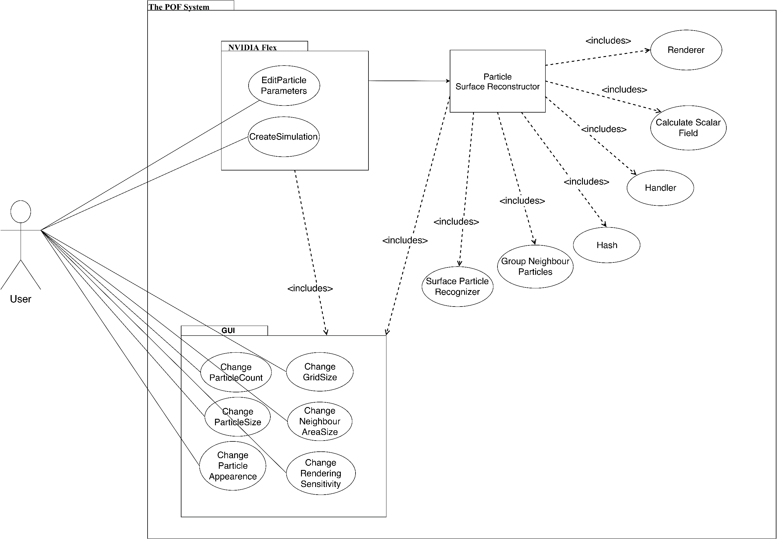***2.2.1 Use Case Diagram***

**Fig 1:** Use case diagram

|  |  |
| --- | --- |
| **Title** | **Description** |
| **Calculate Scalar Field** | Calculates a constant value of a particle in a given range. |
| **Change grid size** | Interval of grid size of axis-aligned bounding box can change with this function. |
| **Change neighbour area size** | Neighbour particle range of volume can be changed. It affects the visualization of particles and changes the shape. |
| **Change particle appearance** | Particle colour, texture and light settings can be changed with this function. |
| **Change particle number** | Changes the particle number in the scene. |
| **Change particle size** | This function changes the radiusof the particle. Excessively disproportionate sizes compared to the scene can result in bugs and anomalies in physics behaviour of the particles |
| **Change rendering sensitivity** | User can change the rendering sensitivitywith this function. If the sensitivity increase, fluid visualization will be more precise as a result. However, the processing time will increase. |
| **Create Simulation** | NVIDIA Flex simulation initialize when this function called. |
| **Edit particle parameters** | Particle attributes can edit by a user from GUI. Parameters can be maximum particle number, particle size, friction, adhesion etc. |
| **Group Neighbour Particles** | Neighbour particles are grouped by looking a specific range. |
| **Handler** | Handler transmits data between layers and relevant classes. The Handler manages data transmission. |
| **Hash** | This function hashes the particle's position and cell position that particle belongs to. |
| **Renderer** | Visualize fluid by drawing the given polygons. |
| **Surface Particle Recognizer** | Surface particles marked andprocessed for the necessary calculations in this function. |
| **User** | Users can be anyone who has access to the program. |

**Table 1:** Description of the use case diagram

**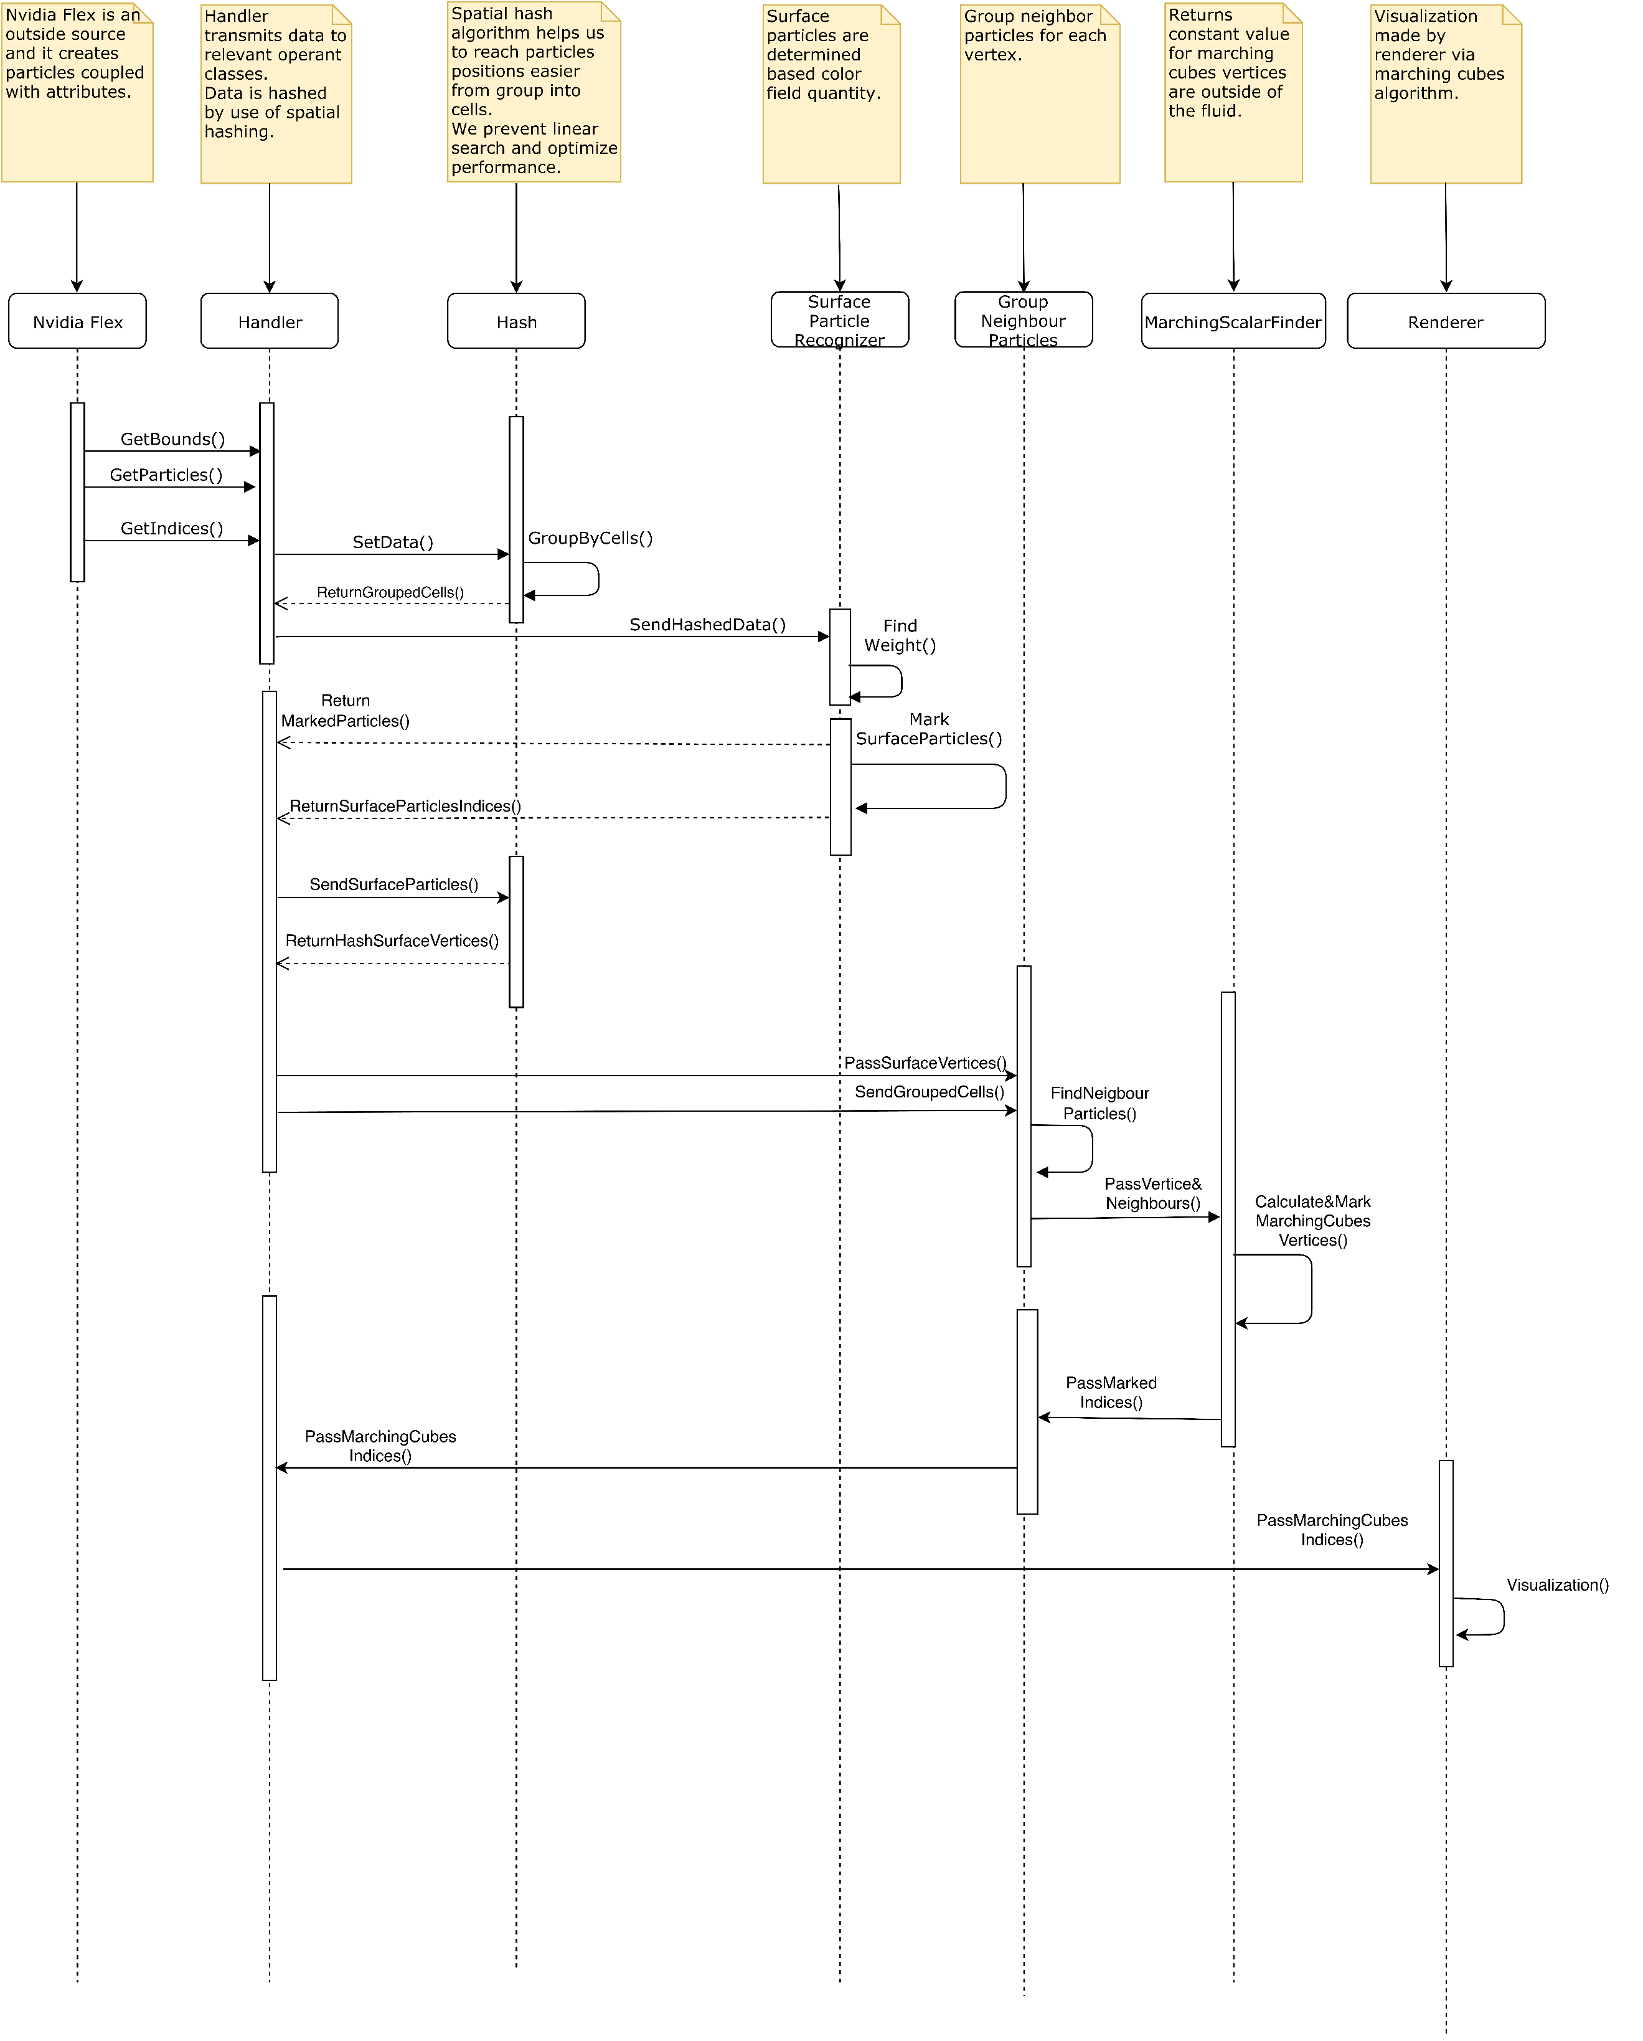*2.2.2 Sequence Diagram***

**Fig 2:** Sequence diagram of the POF system

**Description:**Handler manages data transfer between other sections. If any data has to transmit to another class, Handler executes this operation. NVIDIA flex is an already existed particle-based fluid system that is outsourced and initializes the fluid simulation. Hash applies a special algorithm and makes it easier and faster to store and reach it to particle and cell data. Surface particle recognizer finds the surface particles by computing colour field quantity value. Group neighbour particles function finds a particle's neighbours in a specific range. Marching scalar finder function computes a constant value for the particle vertices that outside of the fluid. Renderer makes the triangulation of the specified vertices and draws the fluid for each frame.

***2.2.3 Class Diagram***

***// Buraya Class diagram gelecek ve baya ayrıntılı olmak zorunda.***

**Fig 3:** Class diagram

**////////////**

**Description:**The package diagram is based on the MVC (model view controller) system. The model section consists of NVIDIA flex and surface particle recognizer. NVIDIA flex creates simulation and can change hydrodynamic attributes of the particles. A surface particle recognizer is another package in the model section. Hash calculates cell id based on the boundaries of cells. The function of calculating the scalar field returns a constant value of the particle. Group neighbour particles compute the weight of a particle by checking nearby particles in a specific range. The marching cubes algorithm determines which vertices will be triangulated. The implementation of Zhu et al. [5] is needed for reconstructing the surface. The controller part has a handler that controls data transmission and communication between sections. View section can change particle attributes such as particle count, size and appearance. Change grid size affects cell sizes. Change neighbour area size can affect the particle rendering. Changing the rendering sensitivity of the rendering affects the appearance of the POF fluid system directly.

///////////////////////////////

# *2.3. POF System Environment*

The POF system environment constraints:

|  |
| --- |
| D3D11 capable graphics card |
| NVIDIA: GeForce Game Ready Driver 372.90 or above. |
| AMD: Radeon Software Version 16.9.1 or above. |
| Microsoft Visual Studio 2013 or above. |
| G++ 4.6.3 or higher |
| CUDA 8.0.44 or higher |
| DirectX 11/12 SDK |
| Windows 7 (64-bit) or higher. |
| Unity 3D 2017.3 version or higher |

The main project made on the system:

|  |  |
| --- | --- |
| Operating System | Windows 10 (64-bit) |
| Processor | Intel Core i7-4700 HQ CPU |
| Memory | 16 GB RAM – DDR3L-1600 MHz |
| GPU | NVIDIA GeForce GTX850M 4GB DDR3 |

This computer system has satisfying performance only small number of particles on this project because it can handle a very small number of particles. The optimal fluid simulation computer system mentioned in the final report [3].

# 3. POF System Detailed Design

This section describes the small parts of the POF system. The functionality of these small parts is explained in activity diagrams.

***3.1 POF system main class***

***// class diagram buraya gelecek.***

***3.2 Subclasses of the POF system***

***// Tüm classların activity diagramları buraya gelecek.***

**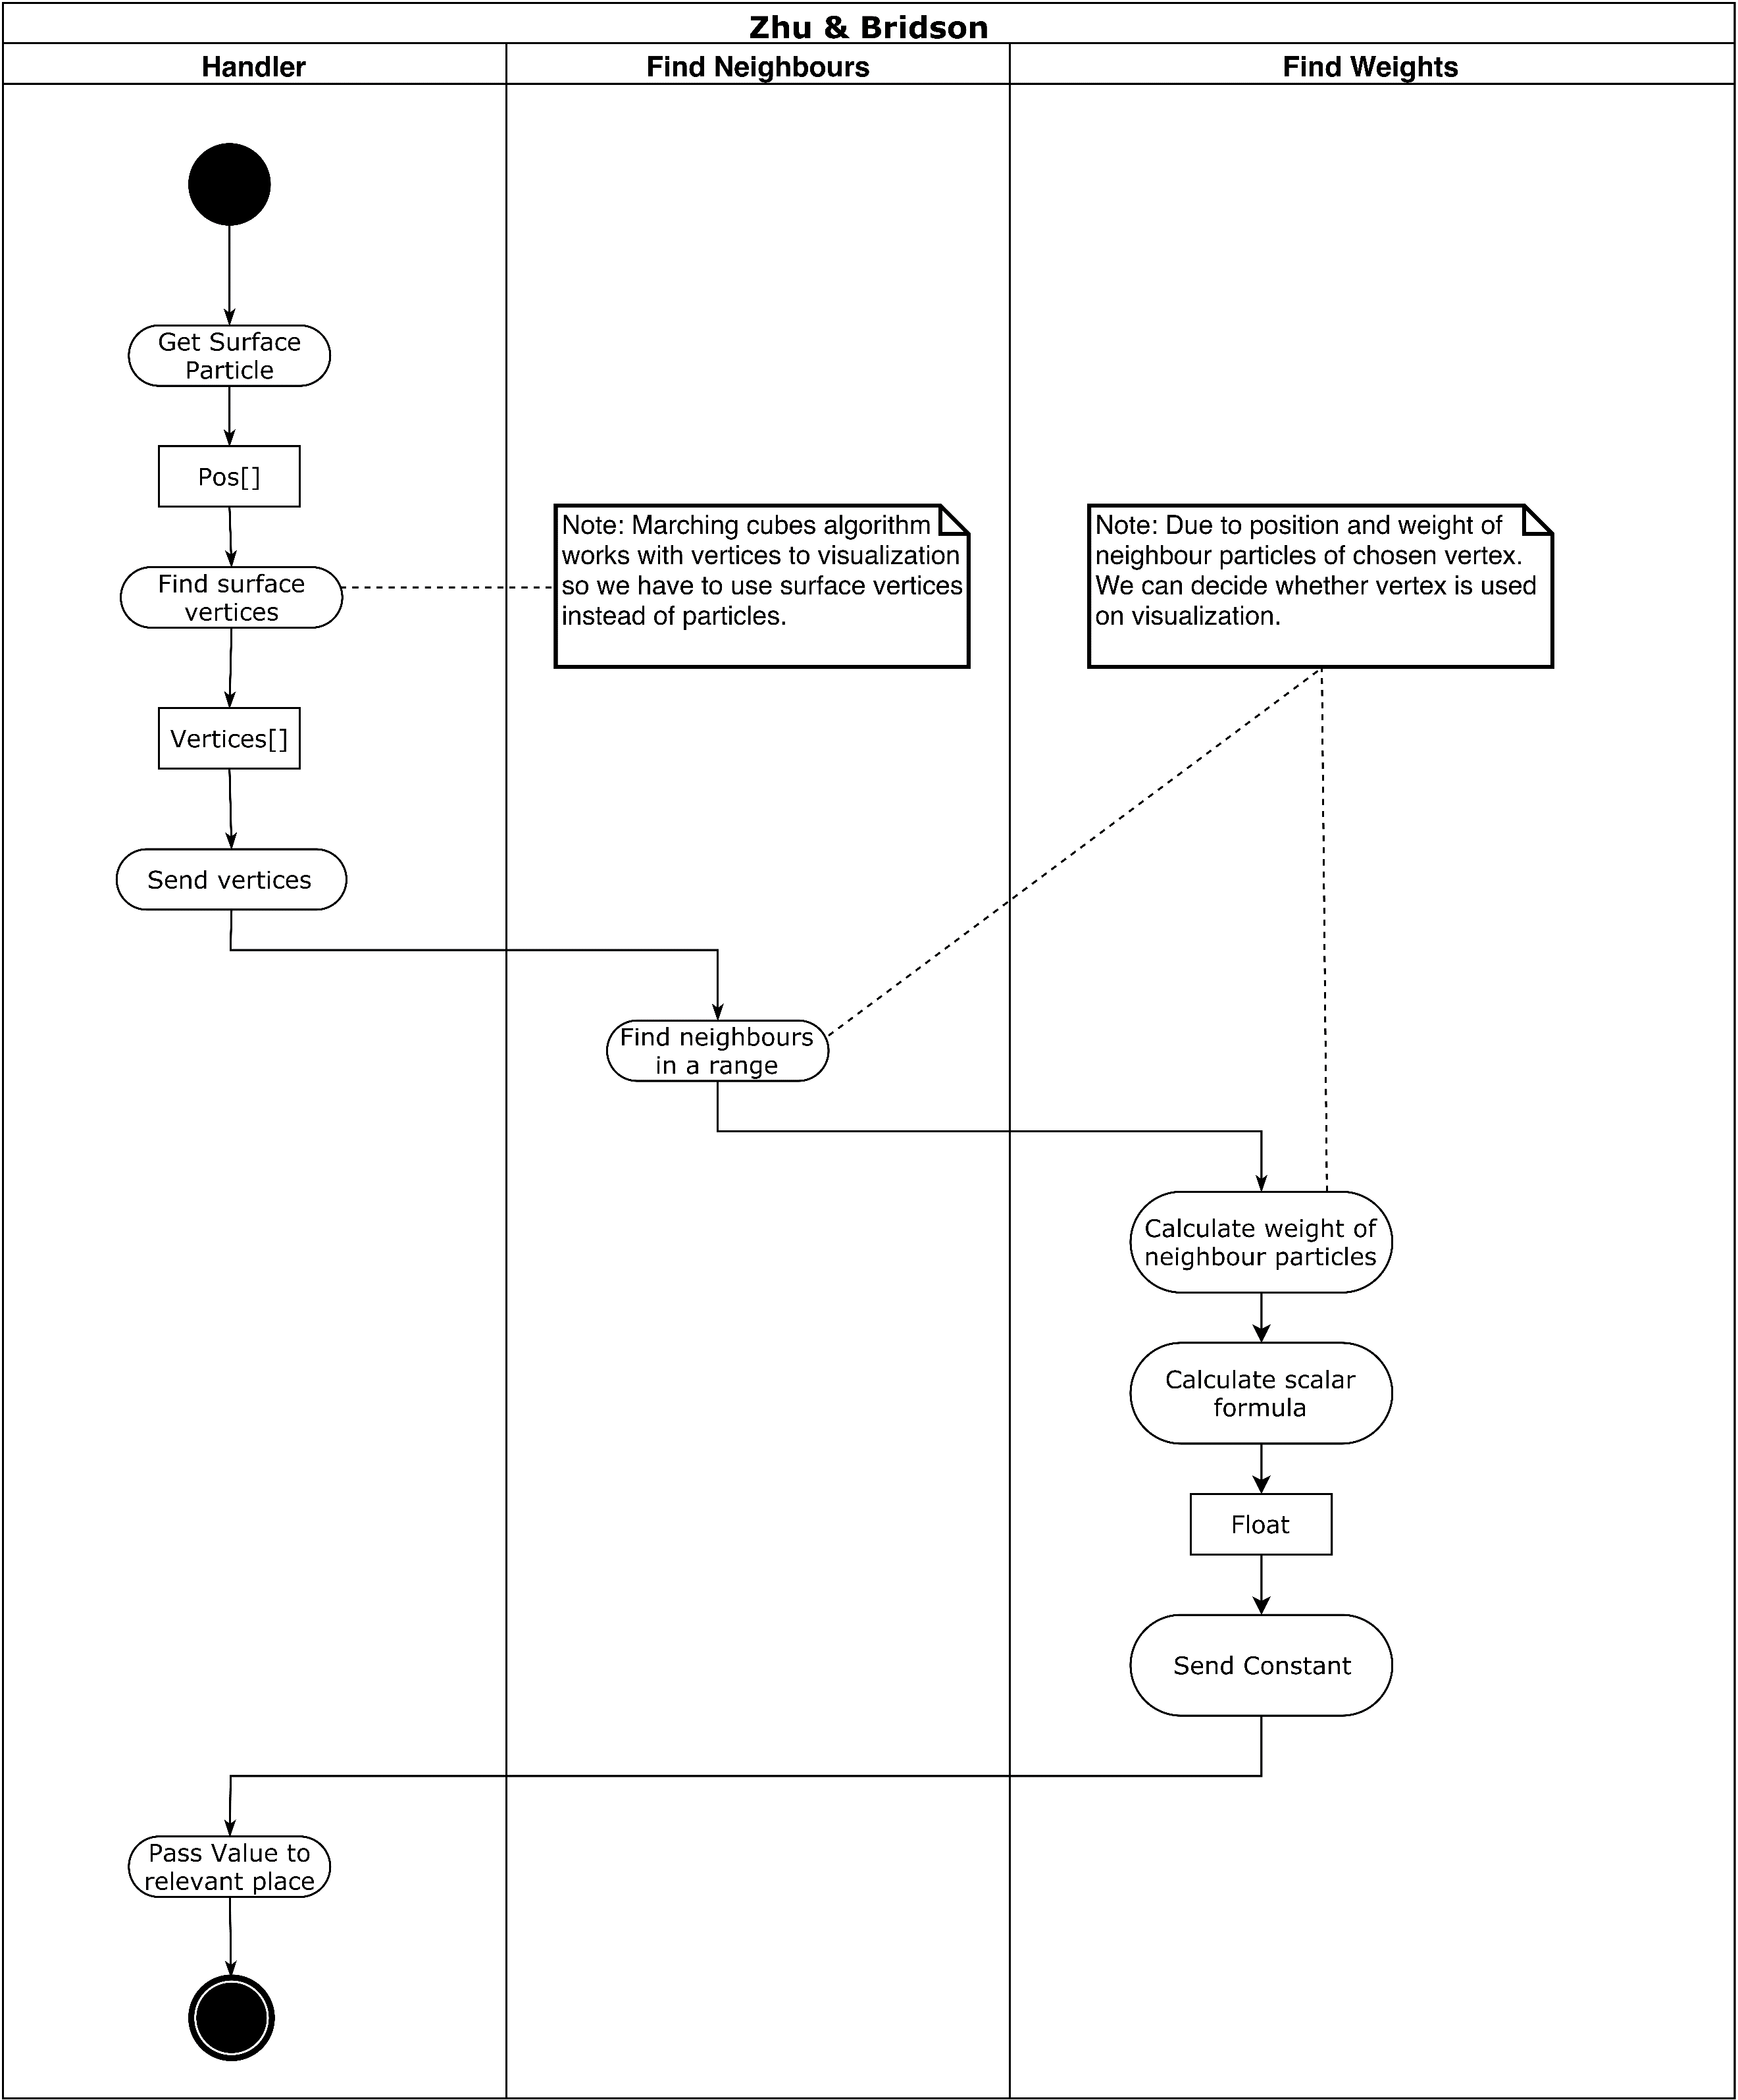*3.1.1 Activity Diagram of Zhu & Bridson***

**Fig 4:** Activity diagram of Zhu&Bridson

**Description:**Handler gets the surface particle from relevant sections. The handler receives the surface vertices and sends it to find neighbours section which is responsible to find neighbours of the particle in a specific range. Find neighbours section transmit neighbour particle data to find weight section. Find weight calculates the weight of the neighbour particles of a specific particle [5]. Weight is used for calculating a scalar value. Find weight returns constant value to the handler. Handler knows pertinent functions to send relevant data.

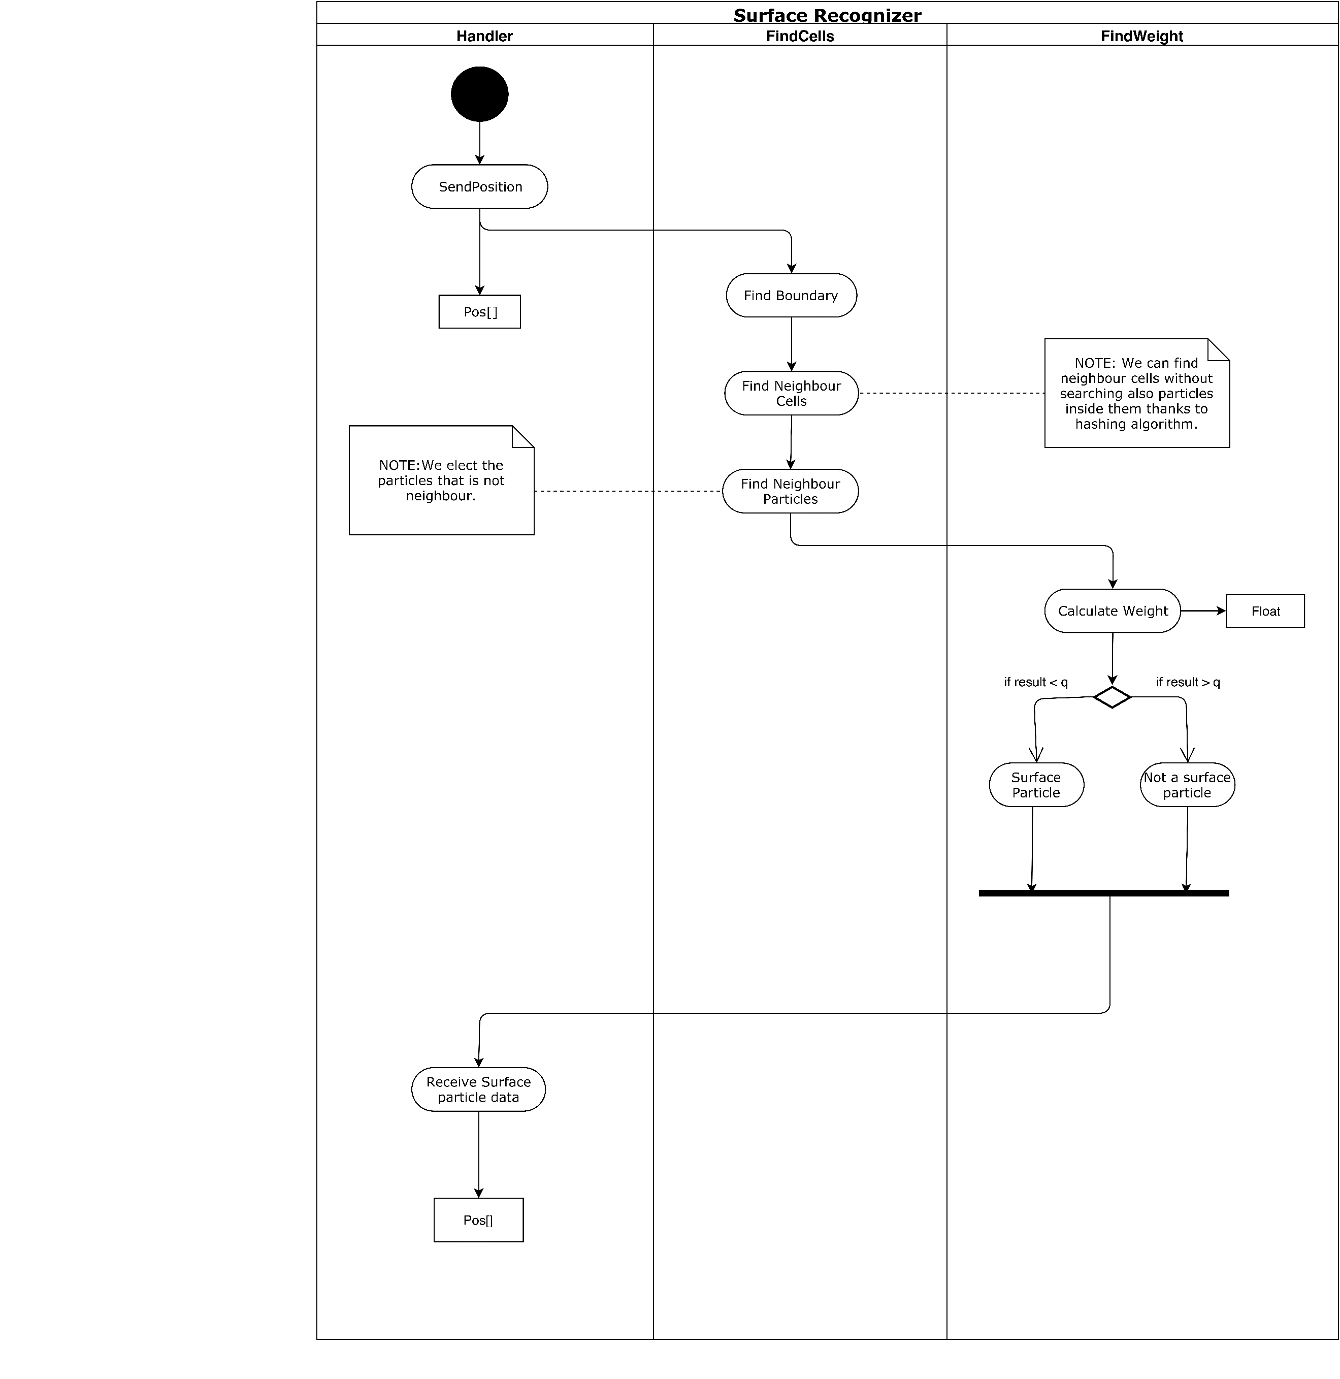***3.1.2 Activity Diagram of Surface Recognizer***

**Fig 5:** Activity diagram of surface recognizer

**Description:** Handlersendsposition data of the particle to find cell function. Find the neighbour cells section to find boundaries and neighbour cells. After that, find cells computes the neighbour particles and disqualify the particles that are not neighbour with each other and passes the data to find weight section. Find weight section calculates the weight and if weight is smaller than specific constant value ‘q’ [8], (This constant called kernel can be changed for much better results in the future implementations of the project.) particle marked as a surface particle. If weight is bigger than a constant value, the particle is not a surface particle. Marked particles are sent to the Handler.

***3.1.3 Activity Diagram of Marching Cubes***

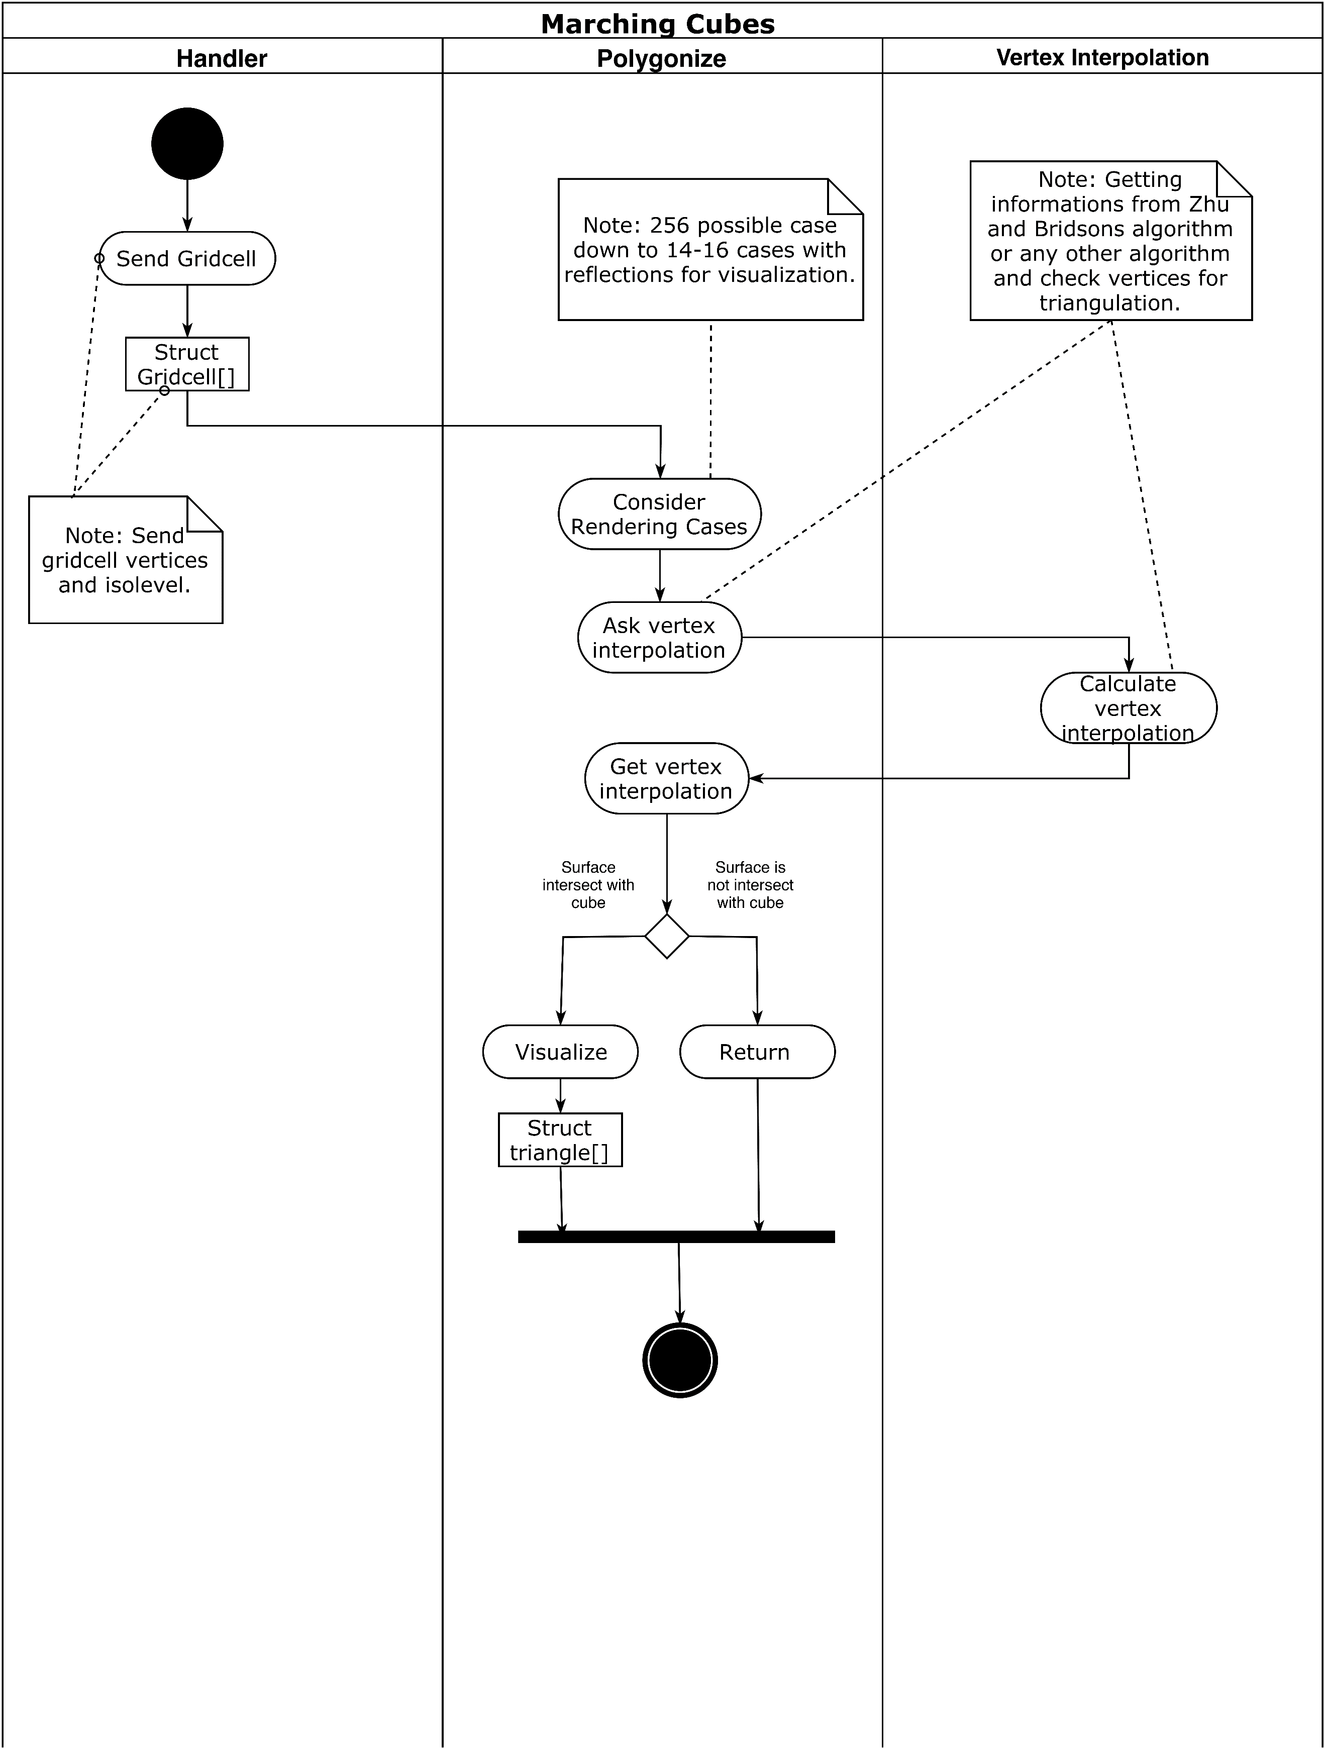

**Fig 6:** Activity diagram of marching cubes

**Description:**Handler sends a grid cell (Cell is a structure consisting of vertices and iso-level) to polygonise function [4]. Polygonise consider rendering by looking cases (There are 16 cases predefined). After that, vertex interpolation calculates a value and returns to polygonise function [5]. If the surface intersects with the cube, the vertex will be visualized. If the surface does not intersect with the cube, the vertex will not be drawn.

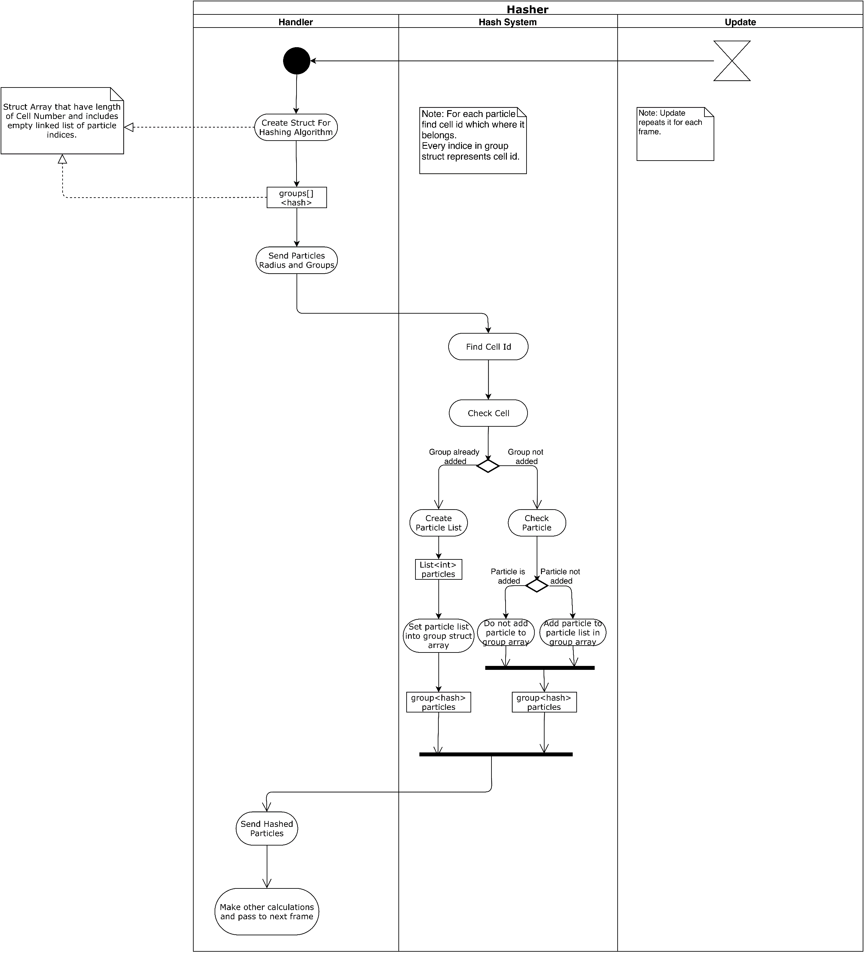***3.1.4 Activity Diagram of Hasher***

**Fig 7:** Activity diagram of hasher

**Description:**Handler sends particle radius and groups to the hash system. Hash system finds the cell that particle includes and checks the cell [9]. If the group already added, the hash system creates a particle list and sets it into the group array and sends hashed particles to the handler. If the group is not added, add the particle to particle list in group array and send hashed particles to the handler.

***3.2.1 POF Main Class***

***//////////////////***

Main module/class is the main program or main process for developments in procedural languages

such as Cobol, Fortran, Pascal, C, and is the main (control) class for developments in object oriented

languages such as C++, Java, C#.

* Detailed design specifications of all methods and internal data in terms of UML Class and Activity

Diagrams

* Discussion and justification of design decisions, if any.

***/////////////////////***

***3.3 POF Subsystem Classes***

***//////////////////////////////***

Class S1-C1 is a class with a number of methods, in case the design target is development in an

object oriented language, such as C++, Java, C#.

* Detailed design specifications of all methods, that is, class internal data in terms of UML Class

Diagram(s) and method logic as UML Activity Diagrams. If method logic is trivial, a single sentence

may be sufficient.

* Detailed design specifications of each user interface, if any, including displays, reports generated, etc

are here.

* Discussion and justification of design decisions, if any.

* Subsection numbering for each method, such as 3.2.1.i for Class S1-C1 Method i may be necessary

if method specification is rather long, covering multiple pages of the document, for a complex class.

Otherwise, a highlihted class name and method name as section name, as shown below, could be

sufficient.

* If detailed design is for developments in procedural languages such as Cobol, Fortran, Pascal, C,

etc., then instead of Class C1, a module specification could be provided. A module in this sense is a

subprogram (procedure, subroutine, function etc. depending on the target procedural language).

////////////////////////////

# 4. Testing Design

// Ufuk hocaya bu kısmı sor

Considering our project is predominantly research and development based, scientific papers and algorithm methods research takes a lot of time. Because of these reasons testing and design changes deferred to the later stages of our project. In this section, we have made integration test design and prove that our code generally work.

***4.1 Hash System***

***4.2 Cell System***

***4.3 Surface Recognition***

***4.4 Finding Neighbours***

***4.5 Tracking Particles***

The comparison tables with details will be added in final report.

# References

1. Final Report revision 1.0
2. Requirement Specification Document revision 2.0 (RSD 2.0)
3. Use case and sequence diagrams in RSD 2.0
4. **[WH87]** William E. Lorensen and Harvey E. Cline. (1987). Marching cubes: A high resolution 3D surface construction algorithm. ACM SIGGRAPH Computer Graphics. 21, 163-169.
5. **[ZB05]** Zhu, Y., & Bridson, R. (2005). Animating sand as a fluid. (New York, NY, USA, 2005) ACM Trans. Graph., 24, 965-972.
6. **[BP94]** Paul Bourke 1994, Marching Cubes, viewed 4 March 2020, **<**[**http://paulbourke.net/geometry/polygonise/**](http://paulbourke.net/geometry/polygonise/)**>**
7. **[SSP07]** Solenthaler, Barbara & Schläfli, Jürg & Pajarola, Renato. (2007). A unified particle model for fluid-solid interactions. Journal of Visualization and Computer Animation. 18. 69-82. 10.1002/cav.162.
8. **[AIA12]** Akinci, Gizem & Ihmsen, Markus & Akinci, Nadir & Teschner, Matthias. (2012). Parallel Surface Reconstruction for Particle-Based Fluids. CGF. 31. 1797-1809. 10.1111/j.1467-8659.2012.02096.x.
9. **[TH03]** Teschner, M., Heidelberger, B., Müller, M., Pomerantes, D., and Gross, M.H. (2003). Optimized Spatial Hashing for Collision Detection of Deformable Objects. VMV.